Institute of technology of Cambodia

Department of Information and communication Engineering



The lesson taking about basic data type and use Boolean, ASCII,

Function string, character.

TP3-Work with String functions

TP: Algorithm and Programming

Lecturer: BOU CHANNA

Student: VEN THON

ID: e20191250

Group: I3-GIC-C

Year: 2021-2022

Table of Contents

Problem1: Write a C program to concatenate a string. The user is required to input his/her first name and last name. the program display username by concatenating the first name and last name together. 3

Problem2: write a c program ask a user for a text. Display the total character of the input string. 4

Problem3: write a c program to get a first name from a user. Find the first letter and last letter of the input first name. 5

Problem4. Write a c program to ask a user to input a piece of text. Convert the text to uppercase. Display on screen both the source input and the converted text. 6

Problem5. Ask a user for a string. Convert it to lowercase. 7

# Problem1: Write a C program to concatenate a string. The user is required to input his/her first name and last name. the program display username by concatenating the first name and last name together.

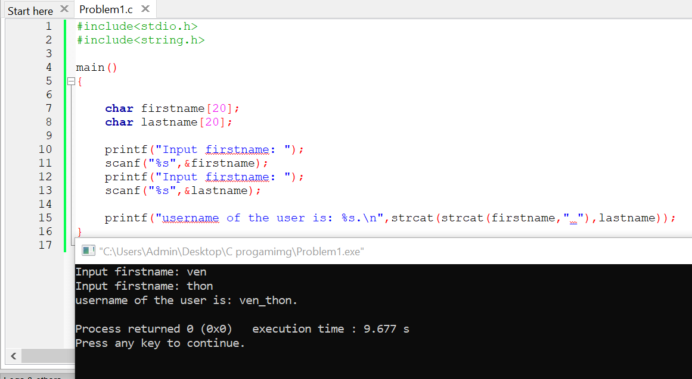

# Problem2: write a c program ask a user for a text. Display the total character of the input string.

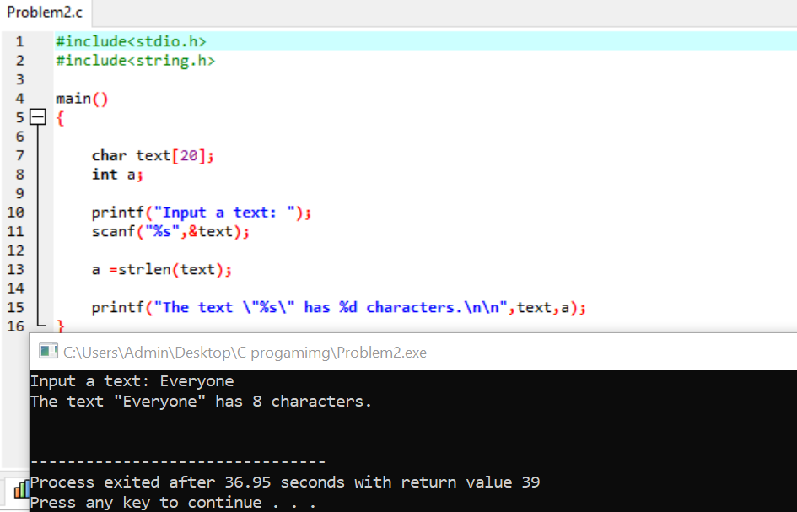

# Problem3: write a c program to get a first name from a user. Find the first letter and last letter of the input first name.

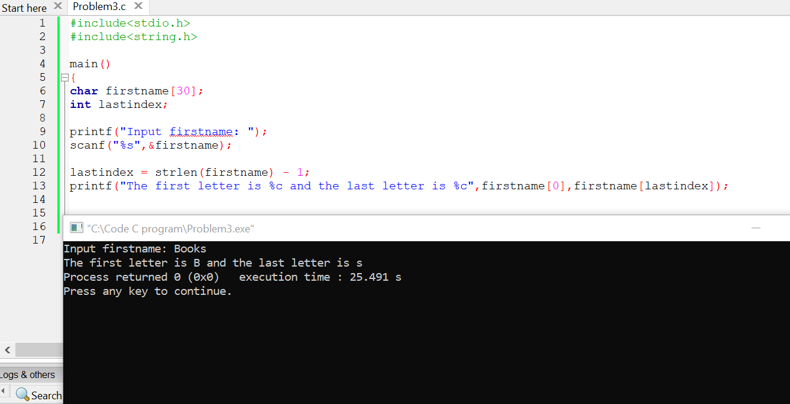

# Problem4. Write a c program to ask a user to input a piece of text. Convert the text to uppercase. Display on screen both the source input and the converted text.

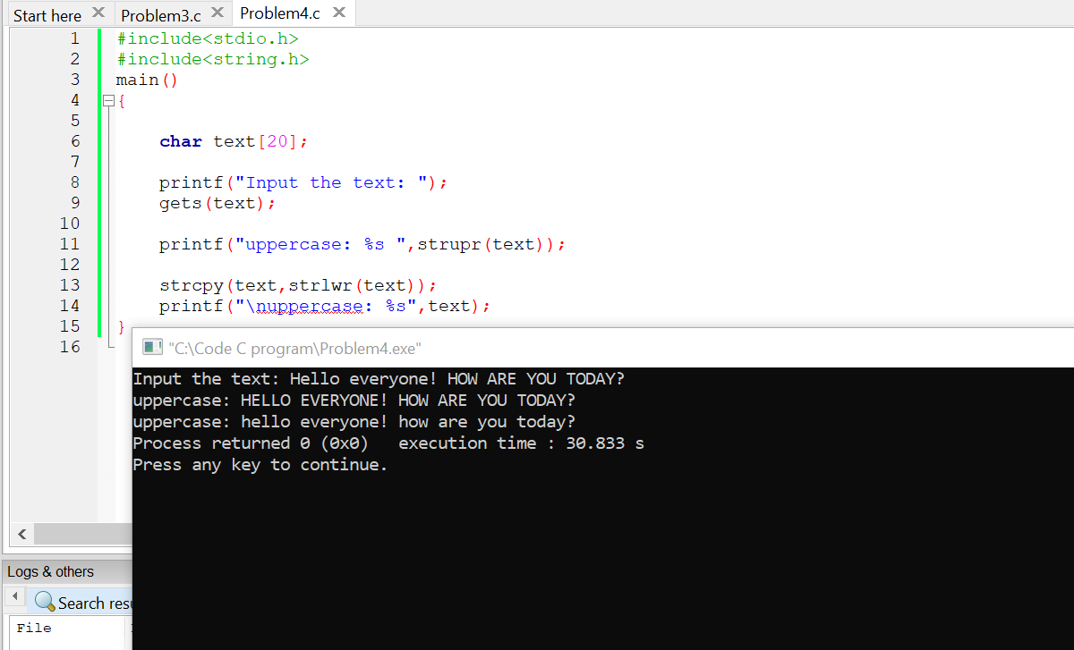

# Problem5. Ask a user for a string. Convert it to lowercase.

